Nama: Aisyah Safira Rachman

Stb: 13020210004

**OUTPUT NOMOR 1**

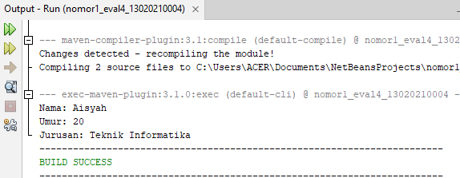

**OUTPUT NOMOR 2**

